**LAB TASK # 10**

**Question # 1 :**

**INPUT :**

using System;

using System.Collections.Generic;

using System.ComponentModel;

using System.Data;

using System.Drawing;

using System.Linq;

using System.Text;

using System.Threading.Tasks;

using System.Windows.Forms;

namespace WindowsFormsApp10

{

public partial class Form1 : Form

{

public Form1()

{

InitializeComponent();

}

private void Form1_Load(object sender, EventArgs e)

{

}

private void comboBox1_SelectedIndexChanged(object sender, EventArgs e)

{

Graphics g = base.CreateGraphics();

Pen p = new Pen(Color.Blue);

SolidBrush sb = new SolidBrush(Color.Brown);

g.Clear(Color.White);

switch (comboBox1.SelectedIndex)

{

case 0:

g.FillEllipse(sb, 50, 50, 150, 150);

break;

case 1:

g.DrawRectangle(p, 50, 50, 150, 150);

break;

case 2:

g.DrawEllipse(p, 50, 80, 150, 170);

break;

case 3:

g.DrawRectangle(p, 50, 50, 50, 50);

break;

}

}

}

}

**OUTPUT :**

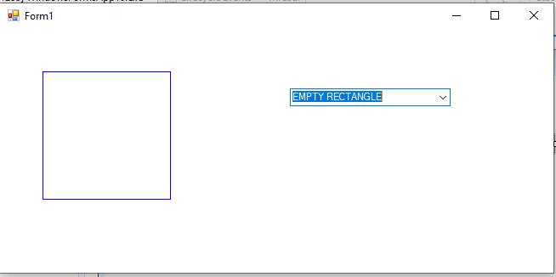

**Question # 2 :**

**INPUT :**

using System;

using System.Collections.Generic;

using System.ComponentModel;

using System.Data;

using System.Drawing;

using System.Linq;

using System.Text;

using System.Threading.Tasks;

using System.Windows.Forms;

namespace WindowsFormsApp9

{

public partial class Form1 : Form

{

public Form1()

{

InitializeComponent();

}

private void Form1_Load(object sender, EventArgs e)

{

Button[] b = new Button[6];

for (int i = 0; i < b.Length; i++)

{

b[i] = new Button();

b[i].Text = "BUTTON " + i;

b[i].Size = new Size(160, 20);

b[i].BackColor = Color.Gray;

b[i].ForeColor = Color.White;

b[i].Location = new Point(20, 20 + (i * 20));

this.Controls.Add(b[i]);

}

}

}

}

**OUTPUT :**

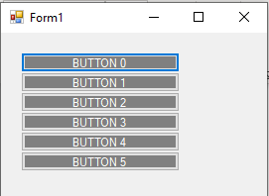

**Question # 3 :**

**INPUT :**

using System;

using System.Collections.Generic;

using System.ComponentModel;

using System.Data;

using System.Drawing;

using System.Linq;

using System.Text;

using System.Threading.Tasks;

using System.Windows.Forms;

namespace WindowsFormsApp2

{

public partial class Form1 : Form

{

public Form1()

{

InitializeComponent();

}

private void Form1_Load(object sender, EventArgs e)

{

Image img = Image.FromFile("d:/1.png");

pictureBox1.Image = img;

}

int count;

private void timer1_Tick(object sender, EventArgs e)

{

if (count == 5)

{

count = 1;

}

pictureBox1.ImageLocation = string.Format(@"d:{0}.png", count);

count++;

}

}

}

**OUTPUT :**

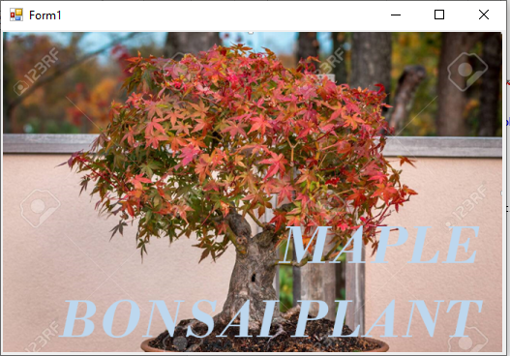

**Question # 4 :**

**INPUT :**

using System;

using System.Collections.Generic;

using System.ComponentModel;

using System.Data;

using System.Drawing;

using System.Linq;

using System.Text;

using System.Threading.Tasks;

using System.Windows.Forms;

namespace WindowsFormsApp9

{

public partial class Form1 : Form

{

public Form1()

{

InitializeComponent();

}

Boolean draw = true;

private void Form1_Load(object sender, EventArgs e)

{

draw = false;

}

private void Form1_MouseUp(object sender, MouseEventArgs e)

{

draw = true;

}

private void Form1_MouseMove(object sender, MouseEventArgs e)

{

if (draw)

{

Graphics g = base.CreateGraphics();

Random r = new Random();

SolidBrush sb = new SolidBrush(Color.Red);

g.FillEllipse(sb, e.X, e.Y, 10, 10);

}

}

private void Form1_MouseDown(object sender, MouseEventArgs e)

{

draw = true;

}

}

}

**OUTPUT :**

